I updated Advanced Advanced Find to the 2014 release and made some improvements along the way. I briefly toyed with the idea of calling it Advanced Advanced Advanced Find, but that would just be silly.
If your not familiar with the app, it works much like the advanced find feature in Vault Explorer. But my app adds the ability to do OR searches across multiple properties.
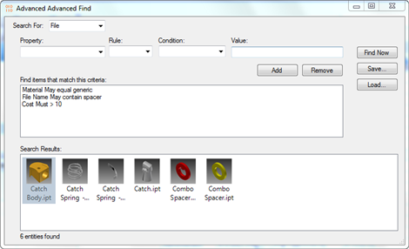
(click for full size image)
New for 2014:
- Save/load feature.
- Results are shown in a Vault Grid Control.
- Double-clicking a result closes the dialog and takes you to the object.

Requirements:
Vault Workgroup/Professional 2014
Click here to download application
Click here to download source
Click here for the 2013 version
As with all the samples on this site, the legal disclaimer applies.

